**SMDM GROUP ASSIGNEMENT- GROUP 9**

**Submitted by**

**Muthukrishnan S (BACJAN19024)**

**Prashanthi D Anand (BACJAN19028)**

**Priya S (BACJAN19029)**

**Sajin Madhavan S (BACJAN19037)**

**Sunandha Akashdeep (BACJAN19048)**

**Q (a). Describe the five percent significance test you would apply to these data to determine whether the new scheme has significantly raised outputs?**

**Solution:**

**Step 1: State the Null & Alternate Hypothesis**

Let,

$μ1$ be the average output by salesperson of old scheme (x)

$μ2$ be the average output by salesperson of new scheme (y)

**Null Hypothesis H0: $μ2≤ μ1$**

**Alternative Hypothesis H1: $μ2>μ1$**

* *The Null Hypothesis states that there is no significantly raised output, in other words there is no increase on the profit.*
* *Whereas, the Alternative Hypothesis states that the new scheme has significantly raised output (Problem statement).*

**Step 2: Data Analysis:**

The data is analyzed before performing hypothesis testing. Initially, the mean and standard deviation of the data are obtained as follows:

* x – Output of the old scheme,
* y – Output of the new scheme,
* Sample size $n=30$.

|  |  |  |
| --- | --- | --- |
|  | **Mean** | **Standard Deviation** |
| Old scheme (x) | 68033.33 | 20255.98 |
| New scheme (y) | 72033.33 | 24062.39 |

The mean of the output of the new scheme is greater than the mean of the output of the old scheme. But this is not enough to come to a conclusion that the new scheme has statistical significance over the old scheme. Hence, a detailed analysis of the sample is necessary to check the outliers and normality.

**Analysis in R:**

**(i) Importing & Viewing Data**

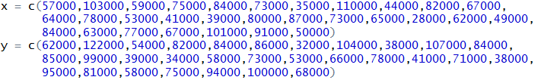

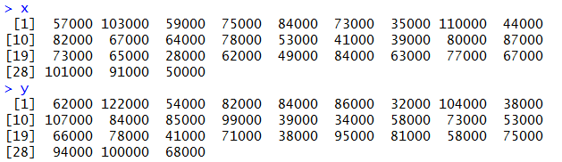

**(ii) Central Measures of the data**

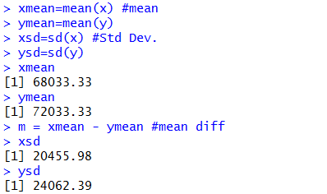

**(iii)Visualizing data:**

Visualizing the data gives more insights about the given data. We use the boxplot and the scatter plot to check if there are any outliers and how far they are symmetrical.

boxplot(x,y)

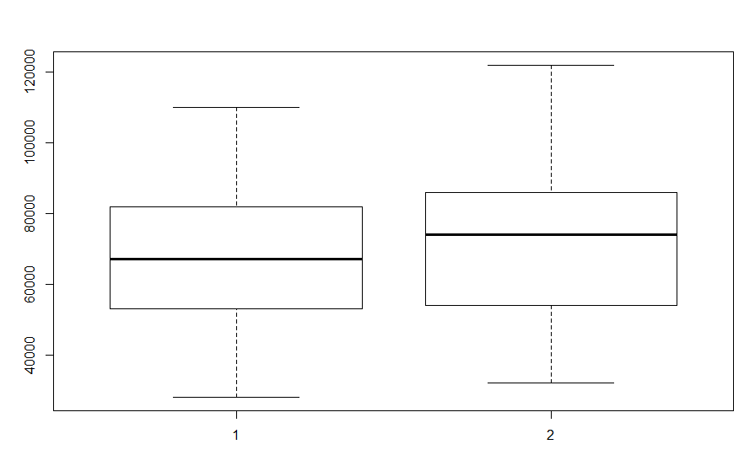

The sample distribution of old sample x seems fairly even, with the median being in the middle of [the box and the whiskers](https://doc.arcgis.com/en/insights/enterprise/latest/create/box-plot.htm#ESRI_SECTION1_0F987E76F57446CEA4F89520FC3AB7DC) being a similar size.The sample distribution of new sample y does looks normally distributed, however the difference between q1 and median is greater than q3 and median.

**(iv) Sample Normality check:**

In this step the sample distribution is analyzed using the Shapiro test. Shapiro test is used to check if the sample is normally distributed or not.

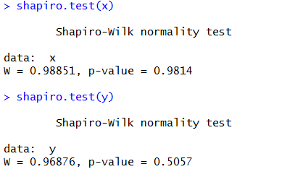

From the output, the p-value is greater than the significance level 0.05 implying that the distributions of the differences are not significantly different from normal distribution. In other words, we can assume the given data follows normality.

**Step 3: Choosing the type of test**

* The question is whether the new scheme (y) has significantly **raised** the output.
* As the population standard deviation is not provided we consider Student’s t distribution.
* The problem states that the sample is taken before and after the new scheme, hence this is paired sample.
* Since the word “Raised” occurs, we consider the test to be a **one-tailed t-test of paired samples.**
* The assumptions of the paired t-test are:

1. The data are continuous (not discrete).
2. The given sample data follows a normal distribution (justified because 30 samples are given -> Central Limit Theorem)
3. The sample of pairs is a simple random sample from its population. Each individual in the population has an equal probability of being selected in the sample

**Step 4: Performing one tailed paired T test using p value approach**

Significance level $α=.05$.

x – Output of the old scheme.

y – Output of the new scheme.

**Below is the one tailed - paired sample t-test using R**

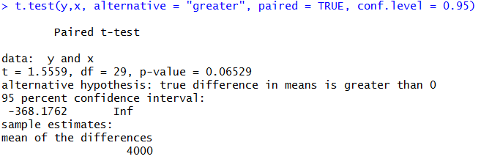

**Q(b). What conclusion does the test lead to?**

By employing p-value of hypothesis testing, probability is calculated to determine if there is enough evidence to reject the null hypothesis. If the p-value is greater than 0.05, that indicates that there is weak evidence against the test, so we would fail to reject the null hypothesis. With the above output, we obtain **p – value as 0.06529.**

***The p-value (=0.06529) is higher than 0.05 (insufficient evidence), so******we fail to reject NULL hypothesis. Based on the given sample, we are 95 % confident that the new scheme has NOT significantly raised outputs”***

**Q(c). What reservations do you have about this result?**

* **The sample size (30)** is not significant to have enough evidence to accept/reject the null hypothesis.
* As it is mentioned in the problem statement “Sales always vary in an unpredictable pattern from month to month”, instead of considering past one month(penultimate) data, **more historical data** (data of past 12 months or so) of the sale can add more justification for the conclusion stated above.
* The given sample is taken in the 4th month after the new incentive scheme is introduced and as mentioned the fluctuation for the first two months were high. So having **more data for the new scheme (5th and 6th month data) will lead to a reliable statistical testing.**
* As mentioned in the lecture, p-value approach is being rejected by the current statistical community because of its inherent bias. As a substitute, false discovery rate can be employed.

**Q(d). Suppose it has been calculated that in order for Titan to break even, the average output must increase by £5000. If this figure is alternative hypothesis, what is: (i)The probability of a type 1 error? (ii) The probability of a type 2 error? (iii) The power of test?**

The below attached is the common table for question (i) and (ii):

|  |  |  |
| --- | --- | --- |
| **Truth about the population** | | |
| **Decision based on sample** | **H0 is True** | **H0 is False** |
| Reject H0 | Type I Error - rejecting H0 when it is true (probability = α) | Correct Decision (probability = 1-β) |
| Fail to Reject H0 | Correct Decision (probability = 1 - α) | Type II Error - fail to reject H0 when it is false (probability = β) |

**(i) The probability of a type 1 error?**

**Solution:**

***Probability of type 1 error is equal to significant level = 0.05 or 5%***

The type 1 error is made if a true null hypothesis is rejected. The probability of making a type I error is α (alpha), which is the level of significance that is set for the hypothesis test. Here, we have our significance level set at an α of 0.05which indicates that we are willing to accept a 5% chance that we go wrong when the null hypothesis is rejected.

**(ii) The probability of a type 2 error?**

**Solution:**

A type 2 error is made if we fail to reject a null hypothesis when it is false. The probability of making a type II error is denoted by β, which also depends on the power of the test.

As it is calculated for company to breakeven, the average output must increase by 5000.

Since, an analysis of the improvement is required, the output of the old sales data is subtracted from the output of the new sales data.

diff = y-x

Let

$μ_{diff}$ = Average difference of the output of salesperson between old and new scheme.

$n = 30$ (sample size)

$α = 0.05$

**Null Hypothesis H0: $μ_{diff}≤ 0$**

**Alternative Hypothesis H1: $μ_{diff}>0$**

* *The Null Hypothesis states that there is no positive change in the difference of the output.*
* *Whereas, the Alternative Hypothesis states that there is an improvement in the output of the new scheme (Problem statement).*

To calculate Type 2 error, we need to calculate the critical value of sample difference when $α=0.05$ as the first step.

$$X=μ_{diff}-T\frac{σ}{\sqrt{n}},$$

Where $T$ denotes critical value based on t-statistics and $σ$ is the standard deviation of the difference of the output of salespersons between old and new scheme.

After calculating the critical value $X$, the probability of type 2 error can be calculated as

$$β=P\left(\overline{X}>X \right)if μ_{diff}=5000$$

$β$ = P (fail to rejecting the null hypothesis |null hypothesis is false) at $μ_{diff}=5000.$

The above is done using R as follow

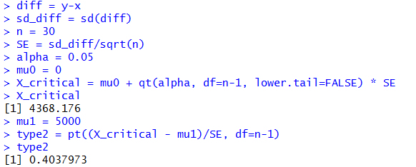

***So the probability of type 2 error is 0.403 or 40.3%***

**(iii) The power of test?**

**Solution:**

***Power of the test: $1-β$ = 1 – 0.403 = 0.596 or 59.6 %***



**Q(e). Are Type 1 and Type 2 errors the same in this case?**

**Solution:**

**No,** the Type 1 and Type 2 error are **not the same** in the given sample data (Type 1 error is 0.05 and Type is 0.403 for our problem)

**Should they be equal? Why or why not?**

**Solution:**

No, Type 1 and Type 2 do not need to be equal. As Type 1 error increases, the probability of Type 2 error decreases. There always exists a tradeoff between Type 1 and Type 2 errors, as we lower the significance level, the power of the test gets lower. If we reduce the significance level (e.g., from 0.05 to 0.01), the [region of acceptance](https://stattrek.com/Help/Glossary.aspx?Target=Region%20of%20acceptance) gets bigger. As a result, you are less likely to reject the null hypothesis when it is false, so you are more likely to make a Type 2 error. However, having small type 1 and type 2 errors can lead to a statistically significant result and this can be achieved by having more samples.

**If they are to be equated, suggest a way to do so. (Hint: would a change in sample size work?)**

**Solution:**

**Increasing the sample size** will increase the power of test (as sampling error decreases). This in turn decreases the Type 2 error such that it could be equated to type 1 error. In our problem, if we increase the sample size to 88 (assuming all other conditions remain the same) probability of type 2 error (0.0494) tends to be approximately equal to type 1 error (0.05).

**Changing the probability of type 1 error $\left(α\right)$** also can change the probability of type 2 error. That is, increasing the type 1 error decrease the type 2 error. In our problem, if we set $α$ as 0.169, probability of type 2 error is approximately equal (0.169). But in reality increasing probability of type 1 error could lead to more serious consequences.

There is also a chance that type 1 and type 2 errors can be the same **if threshold value is different for alternate hypothesis**. In our case if the $μ_{diff}=8735$, type 2 error (0.0500) tends to be approximately equal to type 1 error (0.05). However this way of equating type 1 and type 2 errors by changing the threshold value is not always feasible in real life scenarios. So it is better if we increase the sample size to reduce both the errors.